Movies by Jordie Newton
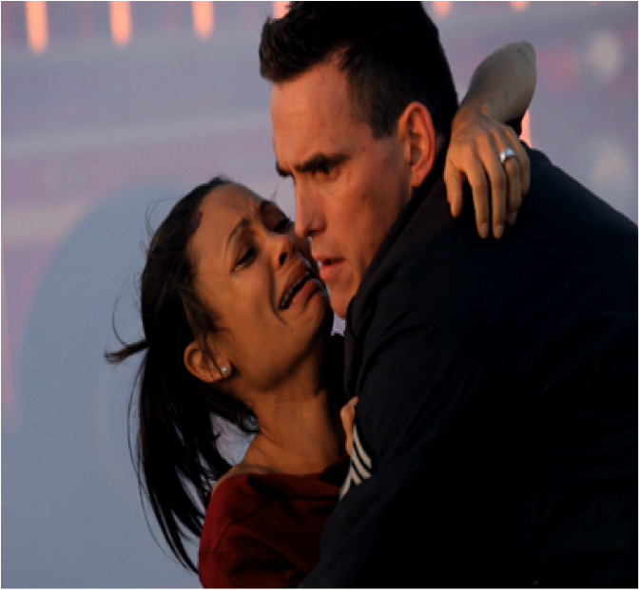
The scoop of where you have seen members of the cast-

Sandra Bullock:
Speed, Miss Congeniality 1&2, Two Weeks Notice, etc.
Don Cheadle:
Devil in a Blue Dress, Traffic, and Things Behind the Sun, etc.
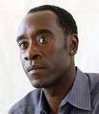
Matt Dillon:
The Outsiders, There’s Something About Mary, etc.

Dillon (right) and Newton stole the show with powerful and emotional acting
Crash
Sandra Bullock, Don Cheadle, Matt Dillon,
Jennifer Esposito, William Fichtner, Brendan
Fraser, Terrance Howard, Chris Bridges,
Thandie Newton, Ryan Phillippe,
Larenz Tate, Michael Pena
I R I
DRAMA
Within the raw, uncensored, and at times disturbing film, Crash delivers a collision of races and culture. It causes viewers to take a
Step back. Director Paul Haggis has outdone himself in this 2005 hit drama. His previous movie he directed was “Million Dollar Baby.” For this film he set the bar higher and created a million-dollar movie, with the hit Crash. Haggis is not afraid to be blunt and not concerned with being subtle. He took risks, which most directors will not, because they are afraid to cross the typical “boundaries of the norm.” For Haggis, his case of the willingness for taking risks, led him to something spectacular.
PEOPLE December 2008 222,sdnfas2222odjksdjfls20002008
“Moving at the speed of life, we are bound to collide with one another.”
Many of the scenes in Crash are schemed to unfold in the viewer’s hands. It intertwines the stories of many lives together to form a society that can feel congested and overwhelming to feeling isolated. The film takes place in L.A., in the heart of the “melting pot” full of different races and cultures.
The film begins and ends with car accidents. In the beginning both women that were driving were of different races. In the first scene, there are racial insults being thrown from an Asian and a Latina woman. This sets the tone, as to what can be expected from the film. The course of the movie is set over 36 hours. During those hours its evident people are worried about themselves and their own situation and the only real communication with someone “different” is by accident. Over the course of the next two days, the role of racial profiling becomes a significant factor. In the film, stereotypes play a huge role.
“Life your life at the point of impact”
PEOPLE December 2008
When a wife of a district attorney (Bullock) sees two black men walking in her midst she feels threatened and immediately clutches onto her husbands arm. In turn the two black teens steal the couple’s vehicle. Once home, Bullock has someone change their locks. She causes a scene because the locksmith was Hispanic, and she said the amigo was going to sell off their key to one of his gang bangers. What Bullock doesn’t know is that the locksmith (Pena) is a family oriented man; with his daughters well-being; his number one priority.
For me one of the key performers in this film was that of the LAPD (Dillon). He portrayed a character that the audience saw as a creep, especially when he was doing a traffic stop and molested a woman. But through his character we can truly see the ranges of people, and how there are flaws in everyone-which doesn’t necessarily mean they are flawed entirely.
There are many cases in this movie where people are stereotyped and are wrongly accused. Crash delivers situations that are emotional tangles, which eventually work out. The fact of the matter is Haggis has done a phenomenal job with creating a film that leaves viewers questioning. The film Crash was anything but a wreck.

